

Save a copy of this document somewhere you can access.

This is ***your*** learning journal. Make sure that you keep it updated as you progress through the Project. Your teacher will let you know when to complete each step. Document both your successes and your failings as they provide the most important learning opportunities!

To get started, please type your name in the following box:

|  |
| --- |
|  |

# Step 1: Define

After watching the video in the [Define](http://app.createbase.co.nz/project/hyperloop/define) step on the platform, read the content and answer the questions below to develop your understanding of the situation and the problem.

## What is a hyperloop?

First of all, what is a hyperloop? A hyperloop is a proposed fifth mode of vehicular transport, after planes, trains, cars and boats.

The hyperloop is not a new concept. In fact, designs can trace their roots back to concepts detailed as early as 1799 by [George Medhurst](https://en.wikipedia.org/wiki/George_Medhurst). The basic concept of a hyperloop involves capsules travelling through a tube at very high speeds. These speeds are achieved by minimising the amount of friction between the capsule and the tube by levitating the capsule and by reducing the amount of air that is present within the tube.

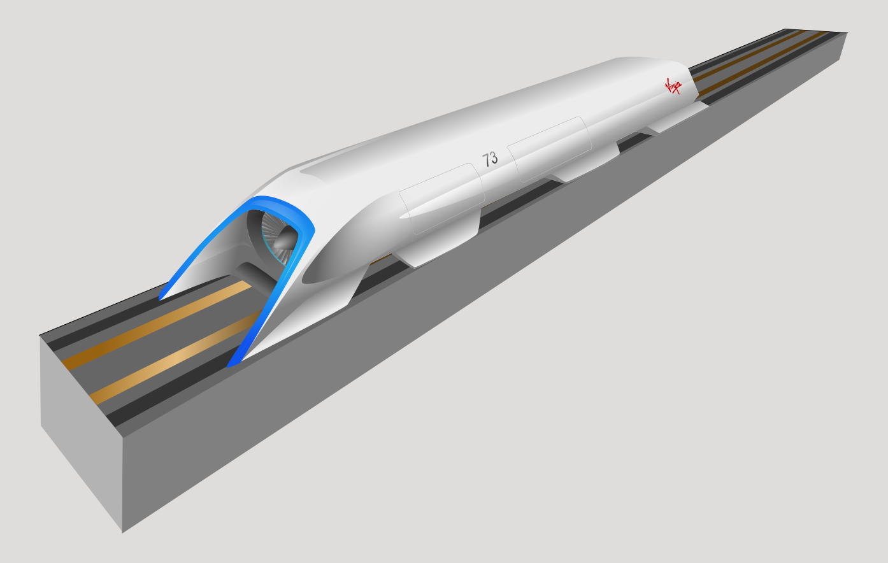

But why bother with hyperloops if we already have perfectly good modes of transportation like cars and trains? Well, when you compare each of the four traditional modes of transportation (planes, trains, cars and boats), they tend to have their own shortcomings:

* Air transportation, like planes, tends to be very fast over long distances. However, it can be very expensive and is actually less time efficient than the other options over very short distances.
* Land and water transportation like cars and boats are more affordable than air travel but tend to be significantly slower over longer distances. Even over shorter distances, congestion caused by too many vehicles (especially for cars) can make short-distance travel time inefficient as well.
* Trains can avoid congestion but are very expensive to build and are not as fast over longer distances than air travel.

Hyperloop is a new mode of transport that attempts to be both fast and inexpensive. Hyperloops take up less space than other transport alternatives like trains and can travel at much faster speeds.

For a little more information about what a hyperloop is, check out the following excerpt from [this white paper](https://www.tesla.com/sites/default/files/blog_images/hyperloop-alpha.pdf) released by Elon Musk in 2013:

“Hyperloop consists of a low-pressure tube with capsules that are transported at both low and high speeds throughout the length of the tube. The capsules are supported on a cushion of air, featuring pressurized air and aerodynamic lift. The capsules are accelerated via a magnetic linear accelerator affixed at various stations on the low pressure tube with rotors contained in each capsule. Passengers may enter and exit Hyperloop at stations located either at the ends of the tube, or branches along the tube length..”

*Note: a magnetic linear accelerator is a device that uses magnetic fields to increase an object's kinetic energy in a single direction. If you want to see how magnets can be used to increase an object's kinetic energy in another context, check out how electromagnets in coilguns could be used to launch satellites or raw materials to orbit.*

Multiple companies are working on the development of hyperloop systems. Check out [this website](https://virginhyperloop.com/) from Virgin Hyperloop that showcases their latest design, and watch this [YouTube video](https://www.youtube.com/watch?v=6hXNXL9PiYk) to find out how their unique system works.

If you want more information, there are many more videos on the topic available on YouTube, like the following two examples. Feel free to watch these videos in your own time or ask your educator to play them for the whole class.

[Hyperloop Explained](https://www.youtube.com/watch?v=zcikLQZI5wQ)

[How Elon Musk's 700 MPH Hyperloop Concept Could Become The Fastest Way To Travel](https://www.youtube.com/watch?v=S5fOWB6SNqs)

## What is the problem?

In our situation video in the Define step, we have a functional hyperloop terminal. We can observe the following from the video:

1. Each capsule in this terminal has an identification number located above the pipe.
2. People arrive with their own passenger number that corresponds to the identification number for one of the hyperloop capsules.
3. A robot stationed at the desk in the hyperloop entranceway assigns each passenger to the correct capsule.

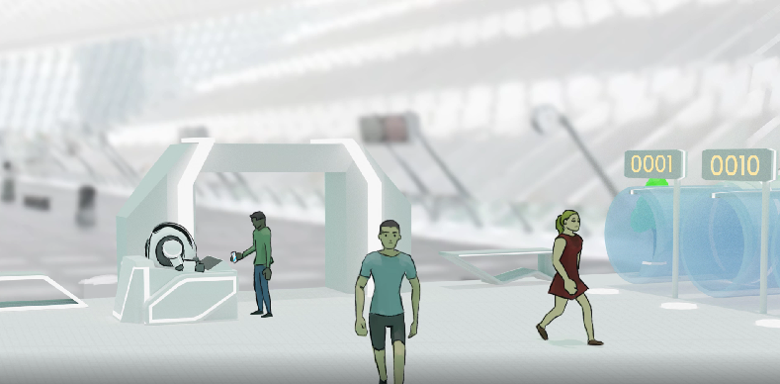

The problem? Well, the numbers that passengers arrive with use a different *number system* to the identification numbers above the hyperloop pipes.

A number system is simply a way to represent numbers using unique symbols. The number system that we are most familiar with is our 0-9 decimal system that was invented somewhere between the 1st and 4th centuries by Indian mathematicians, before being adopted in Arabic mathematics by the 9th. This is not the only way to represent numbers though! For example, tally marks and roman numerals are two other methods of representing numbers.

To help with the task of *converting between these two different number systems*, our robot at the desk has a computer system that can perform any number system conversion. Unfortunately, we can see in the situation video that the computer system that converts the passenger numbers to capsule numbers has malfunctioned! We have been hired to solve this problem and help the robot work out how to assign passengers to the correct hyperloop capsule.

1. **Give the definition of a number system in your own words.** If you do not know what a number system is, try and figure it out by searching for definitions and examples on the internet.

|  |
| --- |
|  |

1. **List 3 things you can observe or extrapolate from the video.**

|  |
| --- |
|  |

1. **Describe the problem that has occurred in the video in your own words.**

|  |
| --- |
|  |

1. **What do you think would happen as a result of this problem?**

Think about the negative impact of this issue in different areas, such as…

* Which people will be directly affected by this problem? Think about the age, jobs or areas they live.
* What daily activities could be affected by this? Think about why the people above might be trying to use the Hyperloop.
* Think about other things that could be affected by this issue that are not people! Plants, animals and the environment.
* Think about the people who might be indirectly affected by this problem. What would they be doing instead if they can’t use the Hyperloop? What problems could this cause or exacerbate (make worse)?

|  |  |
| --- | --- |
| **Who or what would be affected?** | **Describe the negative impact** |
|  |  |

1. **Can you think of at least two advantages and at least one disadvantage to using an automated system to assign passengers to hyperloop capsules compared to a human?**

|  |
| --- |
|  |

## 

# 

# Step 2: Imagine

## Number systems

In this Project, you will be creating an algorithm that the humanoid robot will use to assign incoming passengers to the correct hyperloop capsule. This algorithm will include converting between different number systems.

Return to the platform and navigate to the Imagine section. Read the continents of the first card titled “**What is a number system?”** and then return to your learning journal to answer the following questions:

1. **Give at least one potential reason why the passenger numbers and hyperloop numbers would use different number systems.** Note: the reason doesn’t have to be logical.

|  |
| --- |
|  |

1. **What would the binary number 111 represent in decimal?** Show your working and check how we calculated the value of the number 101 on the platform if you need assistance.

|  |
| --- |
|  |

1. **What would the binary number 10110 represent in decimal?** Show your working and check how we calculated the value of the number 101 on the platform if you need assistance.

|  |
| --- |
|  |

1. **List at least three different reasons why we use different number systems in our modern world (why don’t we use base 10 for everything?).**

|  |
| --- |
|  |

1. **Give at least two potential problems that might arise if different number systems are used for passenger numbers and hyperloop numbers.**

|  |
| --- |
|  |

1. Extra for experts: There are some niche situations where some number systems can be advantageous over others. Let's suppose we are in a scenario where the fraction 1/3 needs to be stored and used to perform very accurate calculations by a computer. **Give one advantage to using a base 3 number system compared to base 10 in this scenario.** Hint: how would you represent 1/3 in base 10 without using a fraction? What about in base 3? Write them down and compare.

|  |
| --- |
|  |

## Our robot

Let's learn a little bit more about our humanoid robot. Return to the Imagine section of the platform, open the second card titled **“Robot capabilities: ticket master”**, read the content and then answer the following questions:

1. **Given the situation where we have incoming passengers and outgoing hyperloop capsules that need to be assigned together using matching numbers, what system or processes would you implement to make sure that passengers are matched with the correct hyperloop capsule? Give at least one answer that involves the robot and at least one answer that does not.**

|  |
| --- |
|  |

Return to the platform and read about what the humanoid robot is capable of and what you will need to complete in this Project to solve the problem.

## Manual controls

Let’s now get an idea of the simulation that we will be using to model the hyperloop terminal. Return to the Imagine section of the platform and click the green “Give it a go” button at the bottom of your screen. You will now have the opportunity to manually control the robot that assigns passengers to the correct hyperloop.

Throughout this Project, you will have to deal with a variety of different number systems for both our incoming passengers and our hyperloop capsules.

In this version of the simulation, passenger numbers will be in base three and hyperloop numbers will be in base thirteen. You will need to manually convert the base three passenger numbers into base thirteen capsule numbers, type in the new number into the input area, and then hit enter on your keyboard to allocate the passenger.

You can try performing the conversions yourself or use the table below as a guide for now.

***Note:*** *observe that:*

* *The base* ***three*** *number 1 is equivalent to the base ten number 1 (1*30 = 1)*
* *The base* ***three*** *number 10 is equivalent to the base ten number 3 (1*31 + 0*30 = 3)*
* *The base* ***three*** *number 100 is equivalent to the base ten number 9 (1*32 + 0*31 + 0*30= 9)*
* *The base* ***thirteen*** *number 1 is equivalent to the base ten number 1 (1*130 = 1)*
* *The base* ***thirteen*** *number 10 is equivalent to the base ten number 13 (1*131 + 0*130 = 13)*
* *We can probably extrapolate this to assume that the base thirteen number 100 would be equivalent to the base ten number 169 (check for yourself if this is correct).*

*Look back at the “What is a number system?” document on the platform and compare this pattern to binary (base two). You should be able to draw the conclusion that a digit D in position N of a number in base B corresponds to a decimal value of D(BN-1). If we calculate this decimal value for each digit in our non-decimal number, we can easily convert any base to decimal.*

|  |  |  |  |  |  |  |  |  |  |  |  |  |  |
| --- | --- | --- | --- | --- | --- | --- | --- | --- | --- | --- | --- | --- | --- |
| **Base thirteen** | 0 | 1 | 2 | 3 | 4 | 5 | 6 | 7 | 8 | 9 | A | B | C |
| **Base ten** | 0 | 1 | 2 | 3 | 4 | 5 | 6 | 7 | 8 | 9 | 10 | 11 | 12 |
| **Base three** | 0 | 1 | 2 | 10 | 11 | 12 | 20 | 21 | 22 | 100 | 101 | 102 | 110 |

|  |  |  |  |  |  |  |  |  |  |  |  |  |  |
| --- | --- | --- | --- | --- | --- | --- | --- | --- | --- | --- | --- | --- | --- |
| **Base thirteen** | 10 | 11 | 12 | 13 | 14 | 15 | 16 | 17 | 18 | 19 | 1A | 1B | 1C |
| **Base ten** | 13 | 14 | 15 | 16 | 17 | 18 | 19 | 20 | 21 | 22 | 33 | 24 | 25 |
| **Base three** | 111 | 112 | 120 | 121 | 122 | 200 | 201 | 202 | 210 | 211 | 212 | 220 | 221 |

Whew, that was a bit annoying. Using a look-up table is certainly a possible solution to any problem that involves finding matching pairs. What happens though when we need to convert a number that is larger than the highest number in our table? What happens if the range of numbers we are converting between is really large?

1. **List at least three potential problems when relying on a human using a physical look-up table to perform conversions. If possible, list a way to alleviate each of these problems.**

|  |
| --- |
|  |

That's it so far for the learning journal! When you have finished answering the questions above, have had a chance to try the manual controls and/or when instructed by your teacher, proceed to the Create step.

In the Create step, you will be presented with multiple subsystems. Each subsystem tests your implementation of a different type of number conversion, progressing in increasing difficulty. These conversions include:

1. Binary to hexadecimal
2. Binary to decimal
3. Decimal to binary
4. Ternary to tridecimal

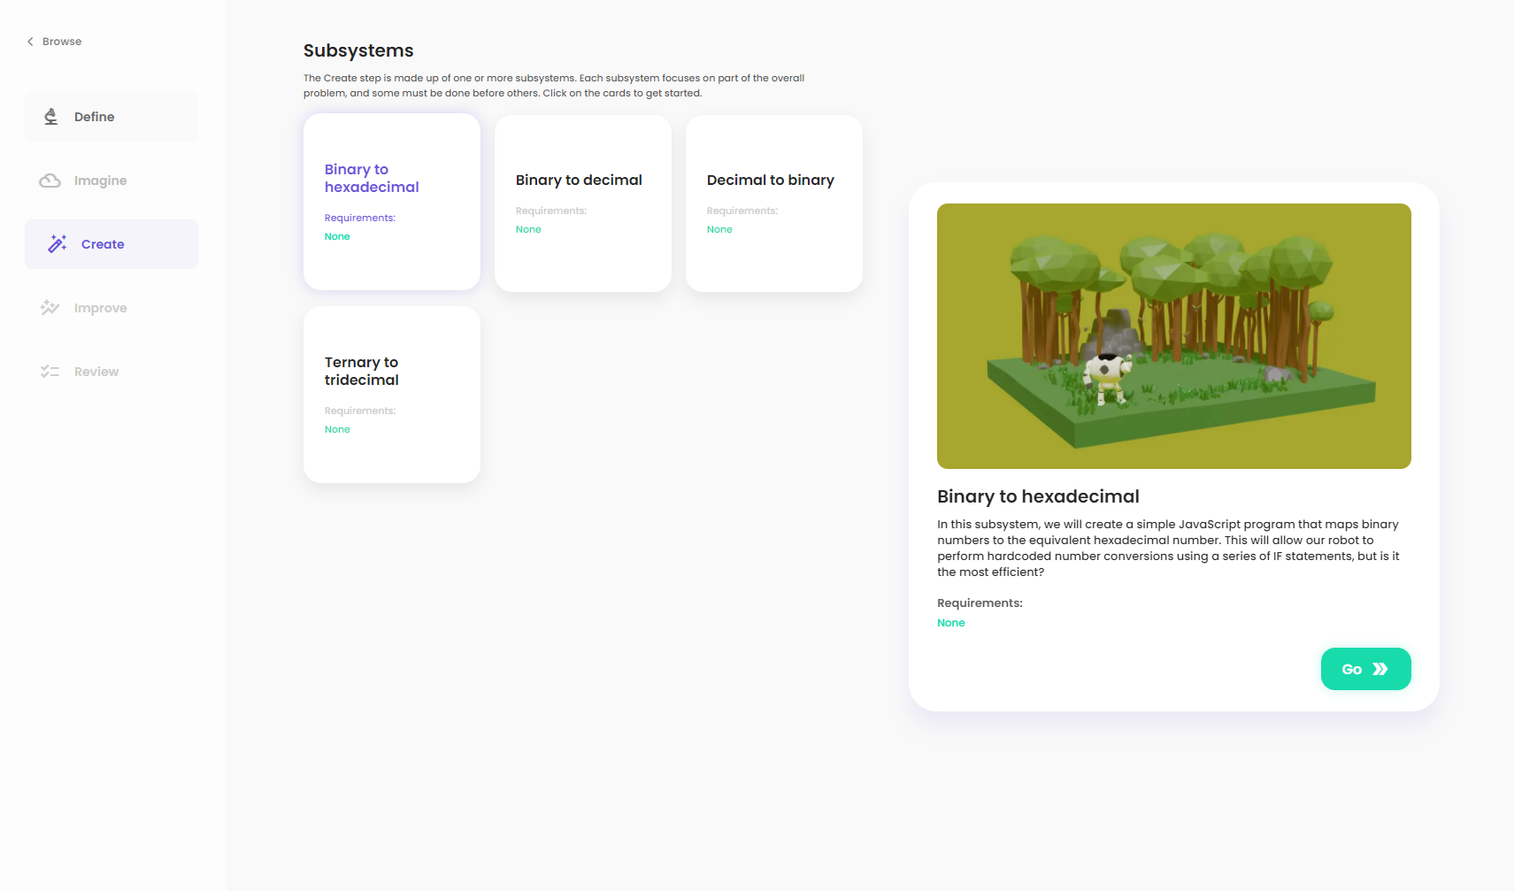

Select the first subsystem, press ”Go”, and then use the contents in the platform to answer the Research, Plan and Code questions in your learning journal below. Rinse and repeat for each subsystem in order until you have successfully completed the entire Create step!

# Step 3: Create

## Subsystem I

### Research

Navigate to the platform and read the [Research](http://app.createbase.co.nz/project/hyperloop/create/Binary%20to%20hexadecimal/research) information for the first subsystem. Then, answer the following questions:

1. **Describe how IF and ELSE IF statements work. Why would we use them in this context?**

|  |
| --- |
|  |

1. **The hyperloop variable is declared as a string rather than an integer. Why is this necessary? Hint: think about how we represent numbers between 9 and 16 using number systems larger than base ten.**

|  |
| --- |
|  |

1. **What would happen in this example code if the passenger’s number was -1?**

|  |
| --- |
|  |

### Plan

In this step, our aim is to understand how to perform a direct mapping between binary and hexadecimal. To do this, let’s attempt to try and answer the following questions.

1. The table below can be used to convert between hexadecimal, decimal and binary number systems for small numbers. **Your task is to fill in the missing numbers as you will use this table as a reference when you write your code.** Check out the table above for base thirteen and base three if you want to remind yourself how we represent decimal numbers higher than ten using other number systems and how we increment the symbol positions.

|  |  |  |  |  |  |  |  |  |  |  |  |
| --- | --- | --- | --- | --- | --- | --- | --- | --- | --- | --- | --- |
| **Base sixteen** | 0 | 1 | 2 | 3 | 4 | 5 | 6 | 7 | 8 |  |  |
| **Base ten** | 0 | 1 | 2 | 3 | 4 | 5 | 6 | 7 | 8 | 9 | 10 |
| **Base two** | 0 | 1 | 10 | 11 | 100 | 101 | 110 |  |  |  |  |

|  |  |  |  |  |  |  |  |  |  |  |  |
| --- | --- | --- | --- | --- | --- | --- | --- | --- | --- | --- | --- |
| **Base sixteen** |  |  |  |  |  |  |  | 12 | 13 | 14 | 15 |
| **Base ten** | 11 | 12 | 13 | 14 | 15 | 16 | 17 | 18 | 19 | 20 | 21 |
| **Base two** |  |  |  |  |  | 10000 | 10001 | 10010 | 10011 | 10100 | 10101 |

Hexadecimal numbers are commonly used to represent colours, and binary numbers are commonly used in computing.

1. **Can you notice any patterns between hexadecimal and binary number systems using the table above? Explain why this pattern emerges.** Hint: completing the table below might help.

|  |
| --- |
|  |

|  |  |  |  |  |  |
| --- | --- | --- | --- | --- | --- |
| Hexadecimal: | 164 = 65,536 | 163 = 4,096 | 162 = 256 | 161 = 16 | 160 = 1 |
| Decimal: | 104 = 10,000 | 103 = 1,000 | 102 = 100 | 101 = 10 | 100 = 1 |
| Binary: | 24 = | 23 = | 22 = | 21 = | 20 = |

### Code

You can now return to the platform and create your code answer as part of the Code step. Make sure that you refer back to the Research and Plan content in your learning journal or the platform whenever you get stuck!

*Hint: don’t forget to declare any variables, like* hyperloop, *before you use them!*

When you have finished with Code, add a screenshot of your final solution below, showing the success screen as well as the text code. Then, write a brief explanation of how it works, including any problems that you encountered along the way and how you overcame them. You may also want to copy and paste your text solution so that you can re-use elements in later subsystems.

|  |
| --- |
|  |

You can now move on to the next subsystem.

## 

## Subsystem II

### Research

In the previous subsystem, we manually typed out a line of code for each possible conversion. If there are only a small amount of combinations, manually typing them all out isn't so bad. However, if we have thousands of combinations, this can get quite tedious. Chaining together a large number of IF-ELSE statements will probably not produce the fastest piece of code either. In addition, we would also have to repeat the entire process again if we wanted to switch to slightly different number systems.

In this subsystem, we will try and solve all of the above problems by creating a smarter algorithm. Although we will be converting between binary and decimal, we will try to design our algorithm to convert all bases between 2 and 9 to decimal.

Return to the platform and read the [Research](http://app.createbase.co.nz/project/hyperloop/create/Binary%20to%20decimal/research) content to learn about one possible algorithm that you can use. When you think that you understand the algorithm, return to this learning journal and answer the following questions:

1. **Using the algorithm in Research or your own algorithm, convert the binary number 11 to decimal. Show your working.**

|  |
| --- |
|  |

1. **Using the algorithm in Research or your own algorithm, convert the binary number 1000 to decimal. Show your working.**

|  |
| --- |
|  |

1. **Using the algorithm in Research or your own algorithm, convert the binary number 10101 to decimal. Show your working.**

|  |
| --- |
|  |

### Plan

Here is the basic framework of ONE possible solution to this problem. You can copy and paste this code into the text editor in the Code step as a starting point, but you will need to replace the three ***TODO*** in order to get it working. Here is a brief explanation of how the code works:

1. A function ConvertToBase10 is declared that takes in numberString a string version of the passenger number and fromBase the base (between 2 and 9) that is being converted into decimal.
2. We then use .split("") to create an array called charArray, of which each entry corresponds to one character (digit) of numberString.
3. The rest of the function implements the algorithm that we defined in the Research step. Note that this function returns the resulting decimal number converted back into a string.
4. The ConvertToBase10 function is called using the number assigned to the next passenger and the number base 2. The output of this function is parsed directly into the MovePersonToHyperloop() function that we used in subsystem 1.

// Subsystem 2: Binary to Decimal

// A function that allows you to convert from bases 2-9 to decimal

let ConvertToBase10 = (numberString, fromBase) => {

// Create the character array. Optional to uppercase for standardization of input

let charArray = numberString.toUpperCase().split("");

// Set the current total to 0

let sum = 0;

// For each position in our number, starting from the far right

for (let i = charArray.length; i > 0; i--) {

// A: Calculate the decimal value of that position.

var value = ***TODO***

// B: Calculate the decimal equivalent of position i by converting the string

// into a number

var parsedNumber = ***TODO***

// C: multiply the results of A and B and add to the current total

***TODO***

}

// Convert the number back to a string

return sum.toString();

}

// The ConvertToBase10 function that we defined above is only run once we call it

// below:

MovePersonToHyperloop(ConvertToBase10(personNumber, 2));

Your job once you move to the Code step is to either:

* Write your own function to convert personNumber into the correct hyperloop number and pass this value into MovePersonToHyperloop()
* Replace the three ***TODO*** in the above code to get it working

Here are some hints to get you started:

**Powers:**

Math.pow(base, exponent) is a function that is equivalent to baseexponent. It may be useful when calculating the decimal value of each position. You will need to replace base and exponent with the correct variables/values.

**The value of i:**

for (let i = charArray.length; i > 0; i--) {} translates to the following:

1. Let i equal the total number of positions in our binary number.
2. As long as the value of i is greater than 0, perform each of the statements within the for loop and then decrease the value of i by one.
3. If the value of i is no longer greater than i at the end of a loop, exit the for loop and proceed to the next line of code.

If our passenger’s number has three positions (three characters in personNumber), then the for loop will run three times with each of the following values for i:

1. 3
2. 2
3. 1

Remember that indexing in JavaScript starts at 0. This means that if you want to extract the third character from charArray, you would need to extract the character at index 2 like follows: charArray[2]

Keep this in mind when using i to index.

**To numbers:**

When converting a string to a number, you can call the parseInt(character) function. This function will convert the input character into an integer number. You might assign the output of this function to the parsedNumber variable. You will need to figure out how to calculate the right character to use as input to the parseInt() function. *Hint: it involves indexing an array.*

**Debugging:**

You can call the console.log(valueOrVariableToPrint) function to print the input to the console tab. This can be useful to double-check that your calculations produce the output you expect. If values are being printed to the console too quickly, you can slow down the simulation using the controls at the top of your screen. You can also clear the console using the trashcan icon in the bottom right corner.

### 

### Code

You can now return to the platform and create your code answer as part of the Code step. Ensure that you refer back to the Research and Plan content in your learning journal or the platform whenever you get stuck!

When you have finished with Code, add a screenshot of your final solution below, showing the success screen and the text code. Then, write a brief explanation of how it works, including any problems you encountered along the way and how you overcame them. You may also want to copy and paste your text solution so that you can re-use elements in later subsystems.

|  |
| --- |
|  |

You can now move on to the next subsystem.

# 

## Subsystem III

### Research

In this subsystem, we will create a different algorithm that is able to do the reverse of the conversions that we did in subsystem 2. Although we will be converting between decimal and binary, we will try to design our algorithm to convert to decimal from all bases between 2 and 9.

Return to the platform and read the [Research](http://app.createbase.co.nz/project/hyperloop/create/Decimal%20to%20binary/research) content to learn about one possible algorithm that you can use. When you think that you understand the algorithm, return to this learning journal and answer the following questions:

1. **Using the algorithm in Research or your own algorithm, convert the decimal number 5 to binary. Show your working.**

|  |
| --- |
|  |

1. **Using the algorithm in Research or your own algorithm, convert the decimal number 10 to binary. Show your working.**

|  |
| --- |
|  |

1. **Using the algorithm in Research or your own algorithm, convert the decimal number 16 to binary. Show your working.**

|  |
| --- |
|  |

1. For experts only: **Convert the decimal number 0.5 to binary. Explain your reasoning.**

|  |
| --- |
|  |

### Plan

Here is the basic framework of ONE possible solution to this problem. You can copy and paste this code into the text editor in the Code step as a starting point, but you will need to replace the three ***TODO*** in order to get it working. Here is a brief explanation of how the code works:

1. A function ConvertFromBase10 is declared that takes in number, a string version of the passenger number and toBase, the base (between 2 and 9) that we are converting to from base 10.
2. We then create an empty array of characters called charList. We will be populating this list with the digits in each of the positions of our converted number.
3. Now I know what you are thinking. “Why is there a FOR loop in the middle of this function? Shouldn’t it be a while loop?” And the answer is yes! It should be a while loop, but the robot’s algorithms get confused during while loops, so we will use this FOR statement instead. We perform eight loops which should be enough to convert any of the decimal numbers that we encounter but feel free to play around with this. However, we don’t need to perform eight calculations, so we use an IF statement to check if our number is still greater than 0. If it is not, then we have already finished converting our number, so we skip to the next iteration.
4. We then divide the current number by the value of the new base, storing the whole number and remainder as variables.
5. We use the remainder variable and the unshift() function to append the value of remainder to the start of our character array. We also update the value of our current number to be equal to the wholeNumber part of our division.
6. The ConvertFromBase10 function is called using the number assigned to the next passenger and the number base 2. The output of this function is parsed directly into the MovePersonToHyperloop() function that we used in the previous subsystems.

// Subsystem 3: Decimal to binary

// A function that allows you to convert from any decimal to bases 2-10

let ConvertFromBase10 = (number, toBase) => {

let charList = [];

// Algorithm for converting to base 10

for (let i = 0; i < 8; i++) {

// While the whole number result is greater than 0

if (***TODO***) {

// Calculate the whole number of the current number divided by the value

// of the base

var wholeNumber = ***TODO***;

// Calculate the remainder of the current number divided by the value of

// the base

var remainder = ***TODO***;

// Assign the remainder to the next highest position in our new number

charList.unshift(remainder.toString());

// Update the value of number to this new value

number = wholeNumber;

}

}

// Join each of the individual characters in our character array into a single

// string

return charList.join("");

}

// The ConvertFromBase10 function that we defined above is only run once we call it

// below:

MovePersonToHyperloop(ConvertFromBase10(personNumber, 2));

Your job once you move to the Code step is to either:

* Write your own function to convert personNumber into the correct hyperloop number and pass this value into MovePersonToHyperloop()
* Replace the three ***TODO*** in the above code to get it working

Here are some hints to get you started:

**Whole numbers:**

Math.floor() is a function that performs the calculation inside the brackets and then returns the answer rounded down to the nearest whole number. For example, Math.floor(2*1.999) would return a value of 3.

**Remainders:**

Do some research into how the % operator works in JavaScript. This operation is similar to most other text-based programming languages and allows you to calculate the remainder of a division.

**Debugging:**

You can call the console.log(valueOrVariableToPrint) function to print the input to the console tab. This can be useful to double-check that your calculations produce the output you expect. If values are being printed to the console too quickly, you can slow down the simulation using the controls at the top of your screen. You can also clear the console using the trashcan icon in the bottom right corner.

### Code

You can now return to the platform and create your code answer as part of the Code step. Ensure that you refer back to the Research and Plan content in your learning journal or the platform whenever you get stuck!

When you have finished with Code, add a screenshot of your final solution below, showing the success screen and the text code. Then, write a brief explanation of how it works, including any problems you encountered along the way and how you overcame them. You may also want to copy and paste your text solution so that you can re-use elements in later subsystems.

|  |
| --- |
|  |

You can now move on to the next subsystem.

# 

## Subsystem IV

### Research

Return to the Research section of the platform, open the second card titled **“Converting between number systems”**, read the content and then answer the following questions:

Let us get some practice on how to convert between two different number systems. Return to the platform and read the [Research](http://app.createbase.co.nz/project/hyperloop/create/Ternary%20to%20tridecimal/research) content, read the content and then answer the following questions:

1. **Convert the base ten number 11 to base three.** Show your working.

|  |
| --- |
|  |

1. **Convert the base ten number 13 to base thirteen.** Show your working.

|  |
| --- |
|  |

1. **Convert the base three number 2 to base thirteen.** Show your working.

|  |
| --- |
|  |

1. **Convert the base three number 101 to base thirteen.** Show your working.

|  |
| --- |
|  |

1. **Convert the base three number 2010 to base thirteen.** Show your working.

|  |
| --- |
|  |

### Plan

If you have successfully completed the first three subsystems and saved your code answers, this subsystem should be easy. Your job is to combine your previous programs, adding a few additional helper functions along the way.

In the next Code step, passenger numbers will have base 3 and hyperloop capsule numbers will have base 13. Therefore, you will be converting from base 3 to base 10 and then to base 13.

Here is a framework for one approach to solving this problem that you could use as a starting point:

//Subsystem 4: Ternary to tridecimal

// The ConvertToBase10 Function needs to be modified slightly to deal

// with numbers A-F using this helper function

let parseCharToInt = (number) => {

if (number == '0') { return 0; }

else if (number == '1') { return 1; }

else if (number == '2') { return 2; }

else if (number == '3') { return 3; }

else if (number == '4') { return 4; }

else if (number == '5') { return 5; }

else if (number == '6') { return 6; }

else if (number == '7') { return 7; }

else if (number == '8') { return 8; }

else if (number == '9') { return 9; }

else if (number == 'A') { return 10; }

else if (number == 'B') { return 11; }

else if (number == 'C') { return 12; }

else if (number == 'D') { return 13; }

else if (number == 'E') { return 14; }

else if (number == 'F') { return 15; }

else { return 0; }

}

// The ConvertFromBase10 Function needs to be modified slightly to deal

// with numbers A-F using this helper function

let parseIntToChar = (number) => {

***TODO***

}

// A function that allows you to convert from bases 2-9 to decimal

let ConvertToBase10 = (numberString, fromBase) => {

***TODO***

return sum.toString();

}

let ConvertFromBase10 = (number, toBase) => {

***TODO***

return charList.join("");

}

// This is an optional additional helper function but allows any input string

// to be converted between any given base from 2-16 to any other base from 2-16

let ConvertBases = (inputNumber, fromBase, toBase) => {

let outBase10 = ConvertToBase10(inputNumber, fromBase);

let output = ConvertFromBase10(parseInt(outBase10), toBase);

return output;

}

MovePersonToHyperloop(ConvertBases(personNumber, 3, 13));

Once you have a plan in mind for how you want to approach writing your code answer, even if you’re going to use the above code as a starting point, then proceed to the final Code step.

### Code

You can now return to the platform and create your code answer as part of the Code step. Ensure that you refer back to the Research and Plan content in your learning journal or the platform whenever you get stuck!

When you have finished with Code, add a screenshot of your final solution below, showing the success screen and the text code. Then, write a brief explanation of how it works, including any problems you encountered along the way and how you overcame them.

|  |
| --- |
|  |

That's it! You now (hopefully) have a working solution. Spend some time helping your classmates, optimising your answer, or moving on to the Improve step.

# 

# Step 4: Improve

Add a screenshot of your final Improve solution below and a brief explanation of how your answer differs from subsystem 4:

|  |
| --- |
|  |

# 

# Step 5: Review

Congratulations on completing the Project! Please type your answers to the following questions:

1. Do you know how to convert between binary and decimal and decimal and binary? If you were asked to do a conversion next week, would you be able to do it on the spot, or would you have to refer back to an algorithm defined here or elsewhere first?

|  |
| --- |
|  |

1. Think about what you achieved during the project. What are you most proud of?

|  |
| --- |
|  |

1. Think about the parts of the project that didn’t go well. List up to **two** of them below. If nothing went terrible, think about things you could have done better.

|  |
| --- |
|  |

1. Choose **one** answer from question 3. Why do you think it didn’t go well? If you redo this Project, what would you do differently to avoid this negative?

|  |
| --- |
|  |

1. During this project, the solution that we built was a program that controlled a robot, enabling it to convert between two different number systems so that incoming passengers could be assigned to the correct hyperloop capsules. This was not the only way to address our problem. In retrospect, do you think that our solution was a good idea? Explain why.

|  |
| --- |
|  |

1. Do you think that there would have been a better solution to this problem than programming a robot to convert between these number systems on the fly? Explain why or why not. If yes, try and provide an alternative solution.

|  |
| --- |
|  |